**Design Document**

**Company Site:** https://agavhe01.github.io/

**Company Name:** Gemma’s Events and Catering

**Purpose:** Equipment hiring and catering. Inventory includes different tents, décor, structures and catering.

**Target:** Businesses and organizations looking to host events, as well as individuals.

**Money-making:** Hiring out equipment and offering catering services. This website will serve as an advertising means to show potential customers the inventory and services available. Portfolio images are crucial to achieve this.

**Design:**

*Header, navbar toggler, image slideshow, image of services, image of motto, footer.*



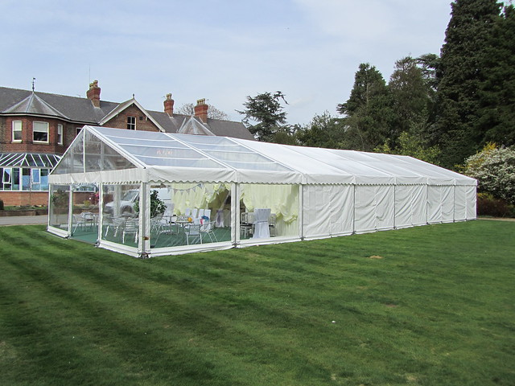

[This Photo](http://flickr.com/photos/churchillmarquees/5640444539) by Unknown Author is licensed under [CC BY-ND](https://creativecommons.org/licenses/by-nd/3.0/)



**Questions:**

**Easiest Part of the Assignment?**

Posting the site to github pages by linking the repository.

Linking the external stylesheet (styles.css) to the html files.

**Most Challenging Part of the Assigment?**

Getting the different front-end elements to align correctly, maintaining design consistency through the CSS rules.

Getting all the hrefs to the other site webpages correct.